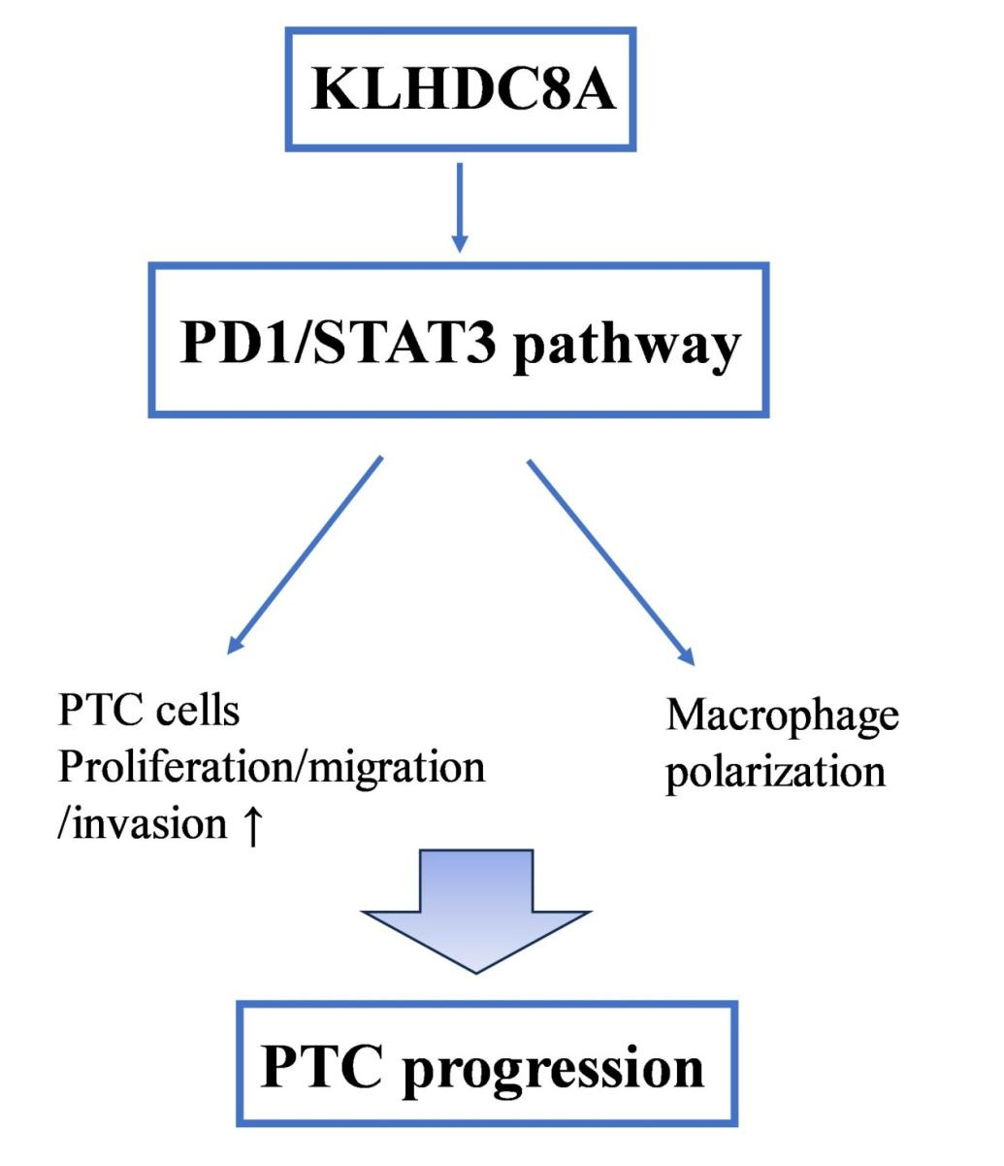
Supplementary Fig. 1. A proposed model for the mechanism of KLHDC8A on papillary thyroid cancer.

